# Name: Nagaraju Emp.ID: 213495

# Title: Bash Scripting

Contents

Title: Bash Scripting 1

Steps: 1

1) Hello World Bash Shell Script 1

2) Simple Backup bash shell script 2

3) Variables in Bash scripts 2

4) Global vs. Local variables 2

5) Passing arguments to the bash script 3

6) Executing shell commands with bash 4

7) Reading User Input 4

8) Bash Trap Command 5

9) Arrays 7

10) Read file into bash array 8

**11)** Bash if / else / fi statements 9

12) Nested if/else 10

13) Bash Comparisons 11

14) Bash File Testing 14

15) Loops 15

16) Bash Functions 19

17) Bash Select 20

18) Case statement conditional 21

19) Bash quotes and quotations 22

20) Arithmetic Operations 24

21) Redirections 28

## Steps:

### Hello World Bash Shell Script

* The following command reveals that the Bash shell is stored in /bin/bash.

$ which bash

/bin/bash

* Hello world bash shell script

*#!/bin/bash*

*# declare STRING variable*

*STRING="Hello World"*

*# print variable on a screen*

*echo $STRING*

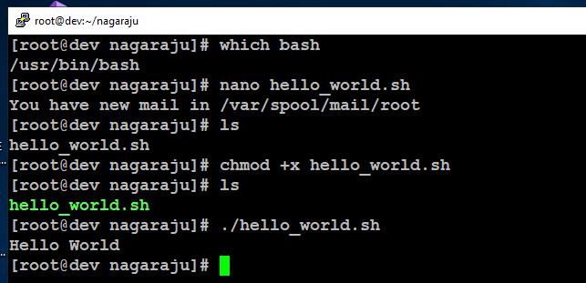

Figure 1: Hello World Script Execution

### Simple Backup bash shell script

*#!/bin/bash*

*tar -czf myhome_directory.tar.gz /home/ansibleraju*

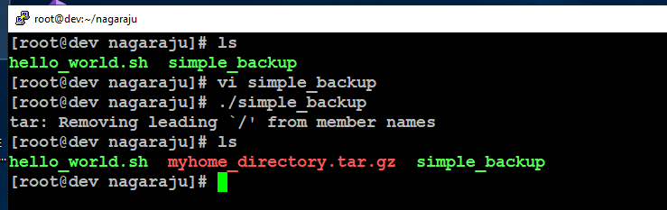

Figure 2: Simple Backup script file creation

### Variables in Bash scripts

*#!/bin/bash*

*STRING="HELLO WORLD!!!"*

*echo $STRING*

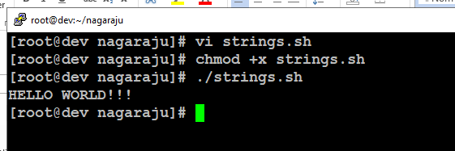

Figure 3: Variables script execution

### Backup with Timestamp:

*#!/bin/bash*

*OF=myhome_directory_$(date +%Y%m%d).tar.gz*

*tar -czf $OF /home/ansibleraju*

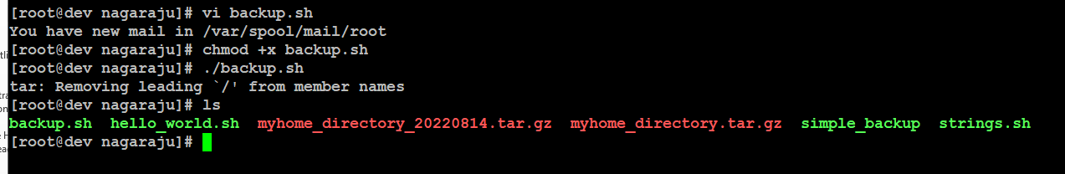

Figure 4: backup with timestamp script exection

### Global vs. Local variables

*#!/bin/bash*

*# Define bash global variable*

*# This variable is global and can be used anywhere in this bash script*

*VAR="global variable"*

*function bash {*

*# Define bash local variable*

*# This variable is local to bash function only*

*local VAR="local variable"*

*echo $VAR*

*}*

*echo $VAR*

*bash*

*# Note the bash global variable did not change*

*# "local" is bash reserved word*

*echo $VAR*

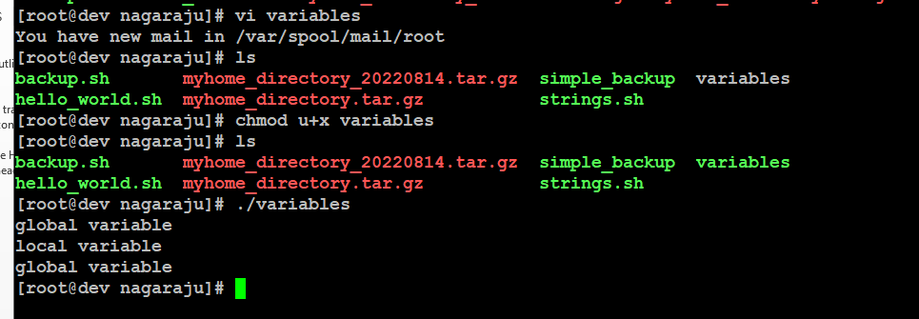

Figure 5: using global and local variables script executed

### Passing arguments to the bash script

*#!/bin/bash*

*# use predefined variables to access passed arguments*

*#echo arguments to the shell*

*echo $1 $2 $3 ' -> echo $1 $2 $3'*

*# We can also store arguments from bash command line in special array*

*args=("$@")*

*#echo arguments to the shell*

*echo ${args[0]} ${args[1]} ${args[2]} ' -> args=("$@"); echo ${args[0]}*

*${args[1]} ${args[2]}'*

*#use $@ to print out all arguments at once*

*echo $@ ' -> echo $@'*

*# use $# variable to print out*

*# number of arguments passed to the bash script*

*echo Number of arguments passed: $# ' -> echo Number of arguments passed: $#'*

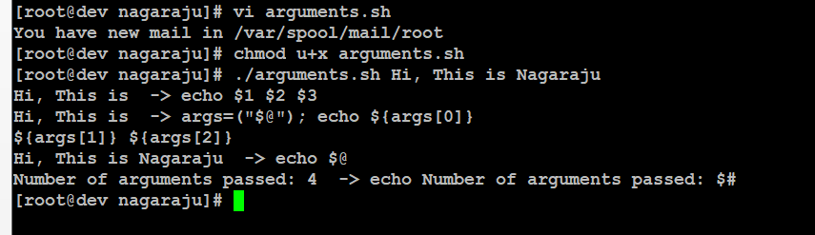

Figure 6: Passing arguments to the script

### Executing shell commands with bash

*!/bin/bash*

*# use a subshell $() to execute shell command*

*echo $(uname -o)*

*# executing bash command without subshell*

*echo uname –o*

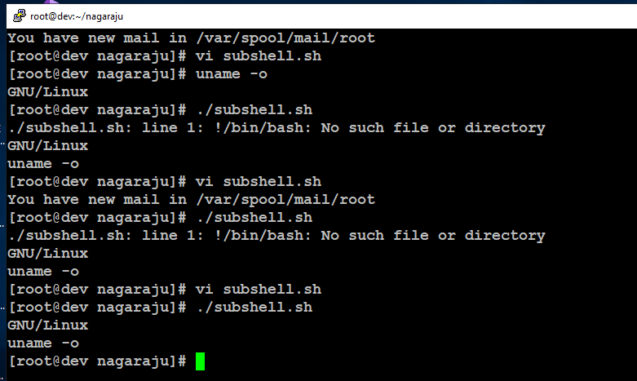

Figure 7: Executing shell commands with bash

### Reading User Input

*#!/bin/bash*

*echo -e "Hi, please type the word: \c "*

*read word*

*echo "The word you entered is: $word"*

*echo -e "Can you please enter two words? "*

*read word1 word2*

*echo "Here is your input: \"$word1\" \"$word2\""*

*echo -e "How do you feel about bash scripting? "*

*# read command now stores a reply into the default build-in variable $REPLY*

*read*

*echo "You said $REPLY, I'm glad to hear that! "*

*echo -e "What are your favorite colours ? "*

*# -a makes read command to read into an array*

*read -a colours*

*echo "My favorite colours are also ${colours[0]}, ${colours[1]} and*

*${colours[2]}:-)"*

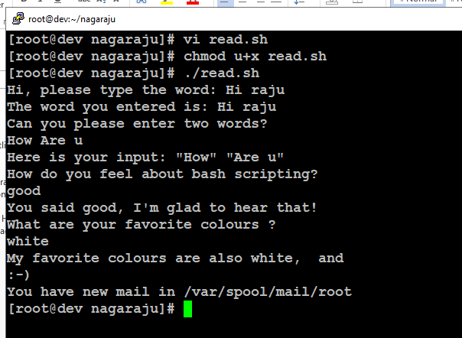

Figure 8: reading user input script

### Bash Trap Command

*#!/bin/bash*

*# bash trap command*

*trap bashtrap INT*

*# bash clear screen command*

*clear;*

*# bash trap function is executed when CTRL-C is pressed:*

*# bash prints message => Executing bash trap subrutine !*

*bashtrap()*

*{*

*echo "CTRL+C Detected !...executing bash trap !"*

*}*

*# for loop from 1/10 to 10/10*

*for a in `seq 1 10`; do*

*echo "$a/10 to Exit."*

*sleep 1;*

*done*

*echo "Exit Bash Trap Example!!!"*

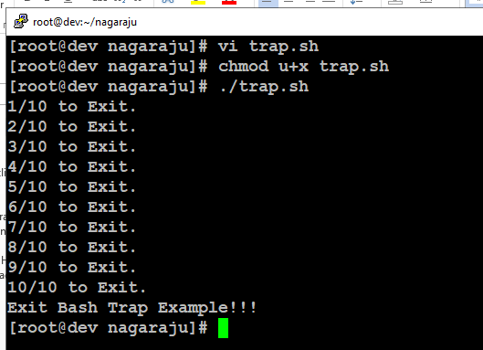

Figure 9: Bash trap command script execution

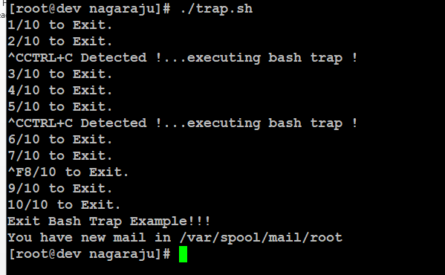

### Arrays

##### Declare simple bash array

*#!/bin/bash*

*#Declare array with 4 elements*

*ARRAY=( 'Debian Linux' 'Redhat Linux' Ubuntu Linux )*

*# get number of elements in the array*

*ELEMENTS=${#ARRAY[@]}*

*# echo each element in array*

*# for loop*

*for (( i=0;i<$ELEMENTS;i++)); do*

*echo ${ARRAY[${i}]}*

*done*

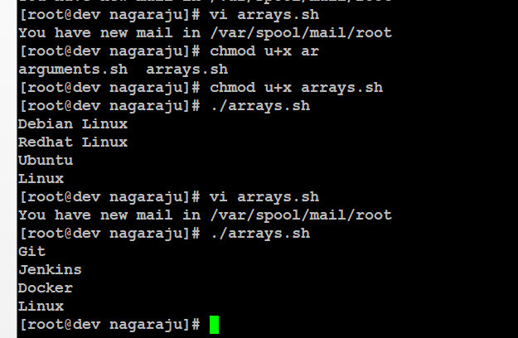

Figure 10: Declare simple bash array

### Read file into bash array

*#!/bin/bash*

*# Declare array*

*declare -a ARRAY*

*# Link filedescriptor 10 with stdin*

*exec 10<&0*

*# stdin replaced with a file supplied as a first argument*

*exec < $1*

*let count=0*

*while read LINE; do*

*ARRAY[$count]=$LINE*

*((count++))*

*done*

*echo Number of elements: ${#ARRAY[@]}*

*# echo array's content*

*echo ${ARRAY[@]}*

*# restore stdin from filedescriptor 10*

*# and close filedescriptor 10*

*exec 0<&10 10<&-*

$ cat bash.txt

Bash

Scripting

Tutorial

Guide

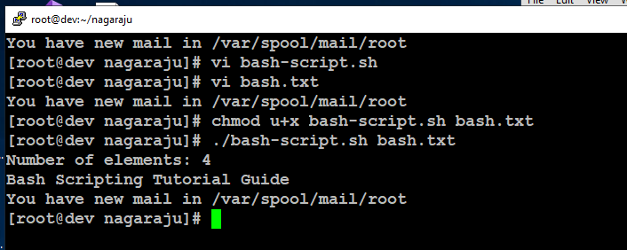

Figure 11: Read file into bash array

### Bash if / else / fi statements

*#!/bin/bash*

*directory="./BashScripting"*

*# bash check if directory exists*

*if [ -d $directory ]; then*

*echo "Directory exists"*

*else*

*echo "Directory does not exist"*

*fi*

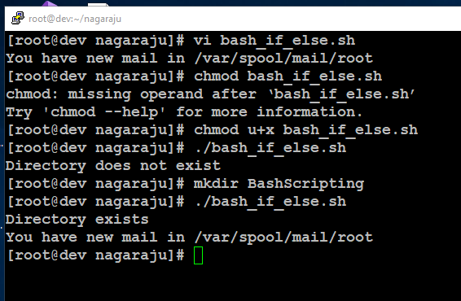

Figure 12: if / else / fi statements

### Nested if/else

*#!/bin/bash*

*# Declare variable choice and assign value 4*

*choice=4*

*# Print to stdout*

*echo "1. Bash"*

*echo "2. Scripting"*

*echo "3. Tutorial"*

*echo -n "Please choose a word [1,2 or 3]? "*

*# Loop while the variable choice is equal 4*

*# bash while loop*

*while [ $choice -eq 4 ]; do*

*# read user input*

*read choice*

*# bash nested if/else*

*if [ $choice -eq 1 ] ; then*

*echo "You have chosen word: Bash"*

*else*

*if [ $choice -eq 2 ] ; then*

*echo "You have chosen word: Scripting"*

*else*

*if [ $choice -eq 3 ] ; then*

*echo "You have chosen word: Tutorial"*

*else*

*echo "Please make a choice between 1-3 !"*

*echo "1. Bash"*

*echo "2. Scripting"*

*echo "3. Tutorial"*

*echo -n "Please choose a word [1,2 or 3]? "*

*choice=4*

*fi*

*fi*

*fi*

*done*

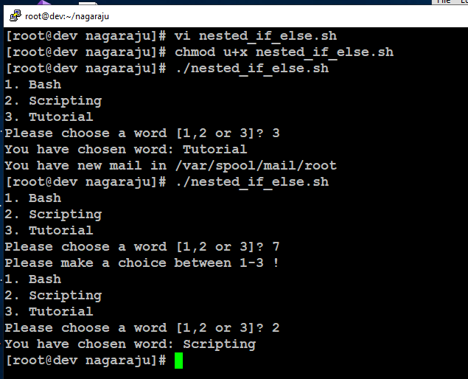

Figure 13: Nested if/else script

### Bash Comparisons

#### Arithmetic Comparisons

*#!/bin/bash*

*# declare integers*

*NUM1=2*

*NUM2=2*

*if [ $NUM1 -eq $NUM2 ]; then*

*echo "Both values are equal"*

*else*

*echo "Values are NOT equal"*

*fi*

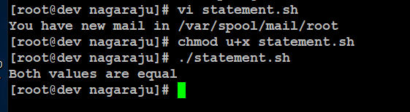

Figure 14: Arithmetic Comparisons script output1

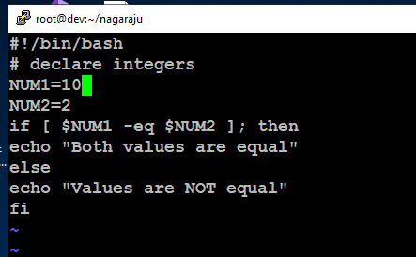

Figure 15: Arithmetic Comparisons script updated

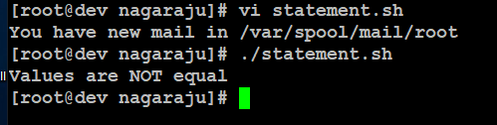

Figure 16: Arithmetic Comparisons script updated output2

* Changing one of the numbers.

*#!/bin/bash*

*# declare integers*

*NUM1=2*

*NUM2=1*

*if [ $NUM1 -eq $NUM2 ]; then*

*echo "Both values are equal"*

*elif [ $NUM1 -gt $NUM2 ]; then*

*echo "NUM1 is greater than NUM2"*

*else*

*echo "NUM2 is greater than NUM1"*

*fi*

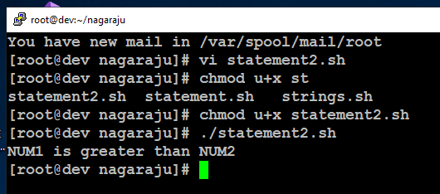

Figure 17: Changed the number and executed

#### String Comparisons

*#!/bin/bash*

*#Declare string S1*

*S1="Bash"*

*#Declare string S2*

*S2="Scripting"*

*if [ $S1 = $S2 ]; then*

*echo "Both Strings are equal"*

*else*

*echo "Strings are NOT equal"*

*fi*



Figure 18: String Comparisons

* Updated Script

*#!/bin/bash*

*#Declare string S1*

*S1="Bash"*

*#Declare string S2*

*S2="Bash"*

*if [ $S1 = $S2 ]; then*

*echo "Both Strings are equal"*

*else*

*echo "Strings are NOT equal"*

*fi*

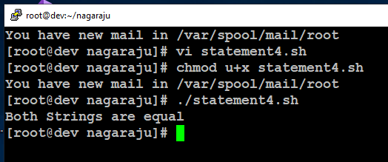

Figure 19: values updated in String Comparisons script

### Bash File Testing

*#!/bin/bash*

*file="./file"*

*if [ -e $file ]; then*

*echo "File exists"*

*else*

*echo "File does not exist"*

*fi*

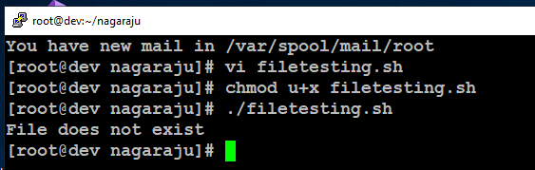

Figure 20: File Testing(exists or not)

$ touch file

$ ./filetesting.sh

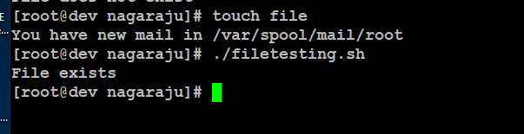

Figure 21: Created file and executed script

* Using while loop

*#!/bin/bash*

*while [ ! -e myfile ]; do*

*# Sleep until file does exists/is created*

*sleep 1*

*done*

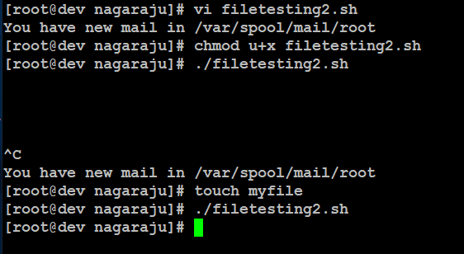

Figure 22: Using while loop if file not present goes to sleep

### Loops

#### Bash for loop

*#!/bin/bash*

*# bash for loop*

*for f in $( ls /var/ ); do*

*echo $f*

*done*

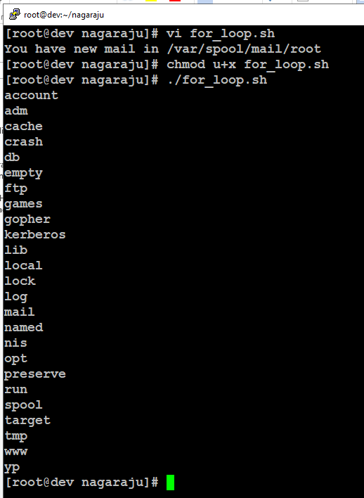

Figure 23: loops script executed

With command

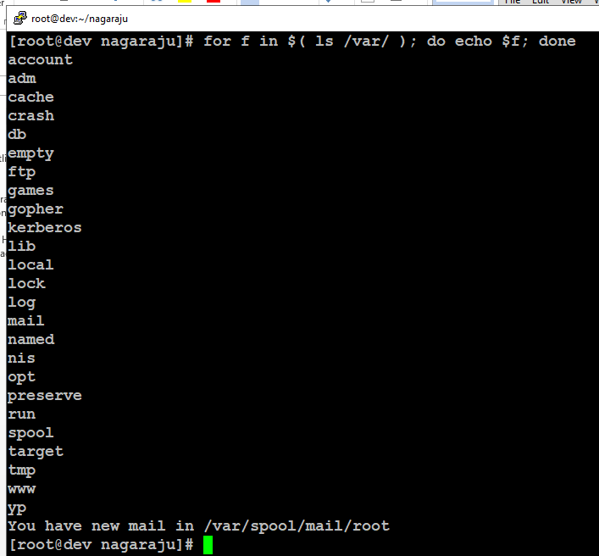

Figure 24: with command executed loops

#### Bash while loop

*#!/bin/bash*

*COUNT=6*

*# bash while loop*

*while [ $COUNT -gt 0 ]; do*

*echo Value of count is: $COUNT*

*let COUNT=COUNT-1*

*done*

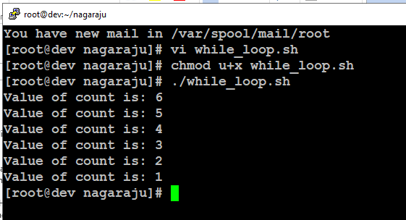

Figure 25: using while loop script executed

#### Bash until loop

*# bash until loop*

*until [ $COUNT -gt 5 ]; do*

*echo Value of count is: $COUNT*

*let COUNT=COUNT+1*

*done*

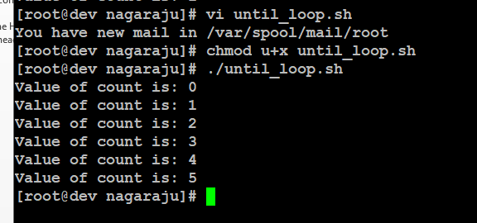

Figure 26: Using until loop script executed

#### Control bash loop with input

*#!/bin/bash*

*# This bash script will locate and replace spaces*

*# in the filenames*

*DIR="."*

*# Controlling a loop with bash read command by redirecting STDOUT as*

*# a STDIN to while loop*

*# find will not truncate filenames containing spaces*

*find $DIR -type f | while read file; do*

*# using POSIX class [:space:] to find space in the filename*

*if [[ "$file" = *[[:space:]]* ]]; then*

*# substitute space with "_" character and consequently rename the file*

*mv "$file" `echo $file | tr ' ' '_'`*

*fi;*

*# end of while loop*

*done*

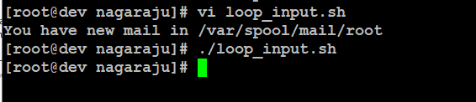

Figure 27: Control bash loop with input

### Bash Functions

*!/bin/bash*

*# BASH FUNCTIONS CAN BE DECLARED IN ANY ORDER*

*function function_B {*

*echo Function B.*

*}*

*function function_A {*

*echo $1*

*}*

*function function_D {*

*echo Function D.*

*}*

*function function_C {*

*echo $1*

*}*

*# FUNCTION CALLS*

*# Pass parameter to function A*

*function_A "Function A."*

*function_B*

*# Pass parameter to function C*

*function_C "Function C."*

*function_D*

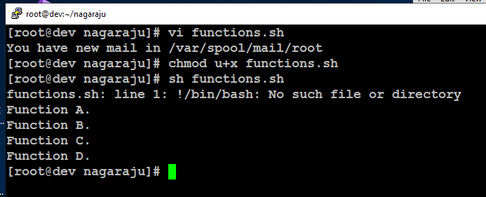

Figure 28: using Functions

### Bash Select

*#!/bin/bash*

*PS3='Choose one word: '*

*# bash select*

*select word in "linux" "bash" "scripting" "tutorial"*

*do*

*echo "The word you have selected is: $word"*

*# Break, otherwise endless loop*

*break*

*done*

*exit 0*

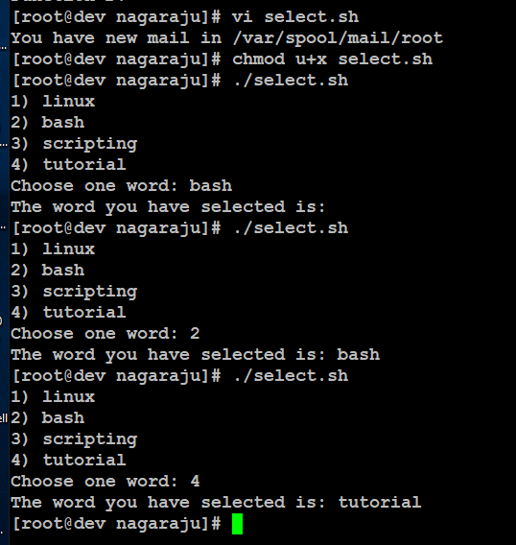

Figure 29: Select script

### Case statement conditional

*#!/bin/bash*

*echo "What is your preferred programming / scripting language"*

*echo "1) bash"*

*echo "2) perl"*

*echo "3) phyton"*

*echo "4) c++"*

*echo "5) I do not know !"*

*read case;*

*#simple case bash structure*

*# note in this case $case is variable and does not have to*

*# be named case this is just an example*

*case $case in*

*1) echo "You selected bash";;*

*2) echo "You selected perl";;*

*3) echo "You selected phyton";;*

*4) echo "You selected c++";;*

*5) exit*

*esac*

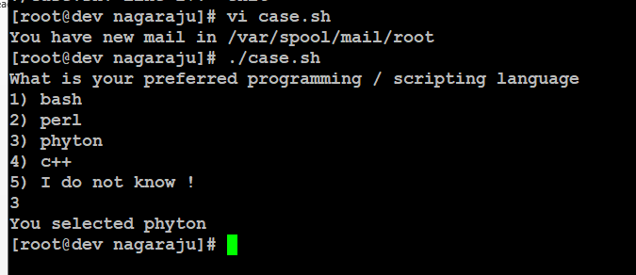

Figure 30: Case statement conditional script executed

### Bash quotes and quotations

*#!/bin/bash*

*#Declare bash string variable*

*BASH_VAR="Bash Script"*

*# echo variable BASH_VAR*

*echo $BASH_VAR*

*#when meta character such us "$" is escaped with "\" it will be read literally*

*echo \$BASH_VAR*

*# backslash has also special meaning and it can be suppressed with yet another "\"*

*echo "\\"*

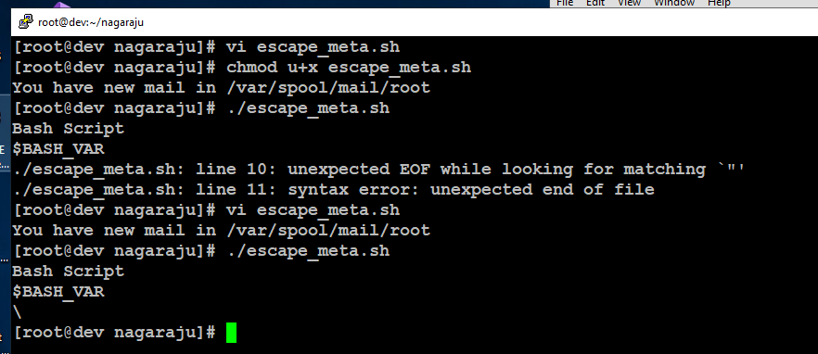

Figure 31: Bash quotes and quotations

#### Single quotes

*#!/bin/bash*

*# Declare bash string variable*

*BASH_VAR="Bash Script"*

*# echo variable BASH_VAR*

*echo $BASH_VAR*

*# meta characters special meaning in bash is suppressed when using single quotes*

*echo '$BASH_VAR "$BASH_VAR"'*

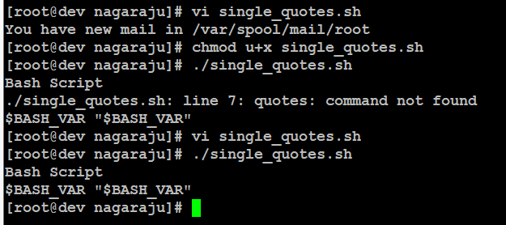

Figure 32: Single quotes

#### Double quotes

*#!/bin/bash*

*#Declare bash string variable*

*BASH_VAR="Bash Script"*

*# echo variable BASH_VAR*

*echo $BASH_VAR*

*# meta characters and its special meaning in bash is*

*# suppressed when using double quotes except "$", "\" and "`"*

*echo "It's $BASH_VAR and \"$BASH_VAR\" using backticks: `date`"*

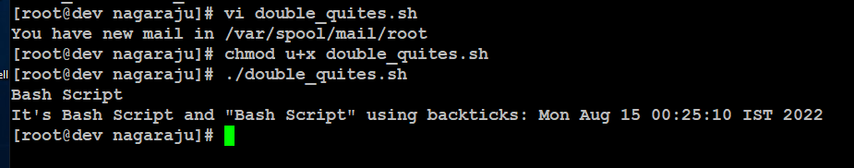

Figure 33: Double quotes

#### Bash quoting with ANSI-C style

*#!/bin/bash*

*# as a example we have used \n as a new line, \x40 is hex value for @*

*# and \56 is octal value for .*

*echo $'web: www.linuxconfig.org\nemail: web\x40linuxconfig\56org'*

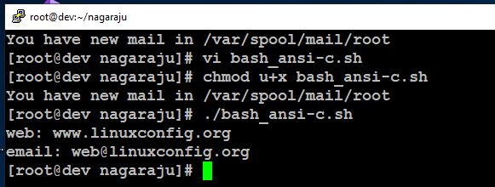

Figure 34: quoting with ANSI-C style

### Arithmetic Operations

Bash Addition Calculator Example

*#!/bin/bash*

*let RESULT1=$1+$2*

*echo $1+$2=$RESULT1 ' -> # let RESULT1=$1+$2'*

*declare -i RESULT2*

*RESULT2=$1+$2*

*echo $1+$2=$RESULT2 ' -> # declare -i RESULT2; RESULT2=$1+$2'*

*echo $1+$2=$(($1 + $2)) ' -> # $(($1 + $2))'*

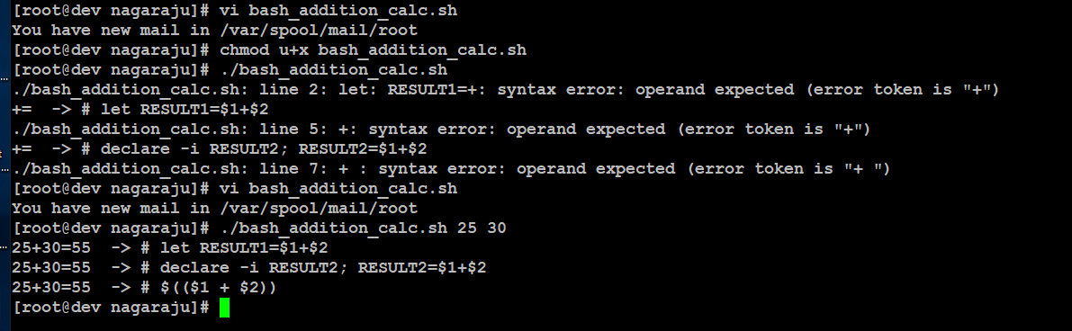

Figure 35: Addition Calculator Example

#### Bash Arithmetic’s

*#!/bin/bash*

*echo '### let ###'*

*# bash addition*

*let ADDITION=3+5*

*echo "3 + 5 =" $ADDITION*

*# bash subtraction*

*let SUBTRACTION=7-8*

*echo "7 - 8 =" $SUBTRACTION*

*# bash multiplication*

*let MULTIPLICATION=5*8*

*echo "5 * 8 =" $MULTIPLICATION*

*# bash division*

*let DIVISION=4/2*

*echo "4 / 2 =" $DIVISION*

*# bash modulus*

*let MODULUS=9%4*

*echo "9 % 4 =" $MODULUS*

*# bash power of two*

*let POWEROFTWO=2**2*

*echo "2 ^ 2 =" $POWEROFTWO*

*echo '### Bash Arithmetic Expansion ###'*

*# There are two formats for arithmetic expansion: $[ expression ]*

*# and $(( expression #)) its your choice which you use*

*echo 4 + 5 = $((4 + 5))*

*echo 7 - 7 = $[ 7 - 7 ]*

*echo 4 x 6 = $((3 * 2))*

*echo 6 / 3 = $((6 / 3))*

*echo 8 % 7 = $((8 % 7))*

*echo 2 ^ 8 = $[ 2 ** 8 ]*

*echo '### Declare ###'*

*echo -e "Please enter two numbers \c"*

*# read user input*

*read num1 num2*

*declare -i result*

*result=$num1+$num2*

*echo "Result is:$result "*

*# bash convert binary number 10001*

*result=2#10001*

*echo $result*

*# bash convert octal number 16*

*result=8#16*

*echo $result*

*# bash convert hex number 0xE6A*

*result=16#E6A*

*echo $result*

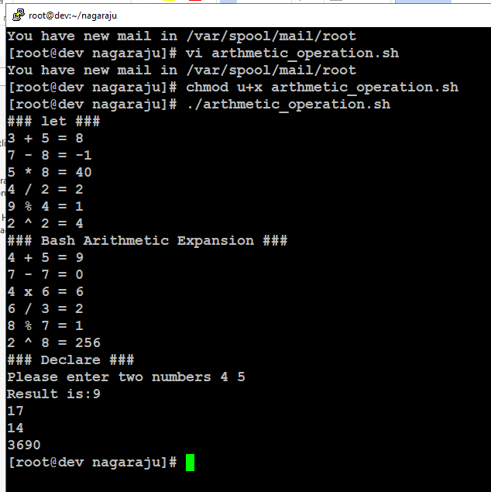

Figure 36: Arithmetic’s

#### Round floating point number

*#!/bin/bash*

*# get floating point number*

*floating_point_number=3.3446*

*echo $floating_point_number*

*# round floating point number with bash*

*for bash_rounded_number in $(printf %.0f $floating_point_number); do*

*echo "Rounded number with bash:" $bash_rounded_number*

*done*

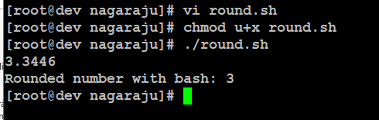

Figure 37: Round floating point number

#### Bash floating point calculations

*#!/bin/bash*

*# Simple linux bash calculator*

*echo "Enter input:"*

*read userinput*

*echo "Result with 2 digits after decimal point:"*

*echo "scale=2; ${userinput}" | bc*

*echo "Result with 10 digits after decimal point:"*

*echo "scale=10; ${userinput}" | bc*

*echo "Result as rounded integer:"*

*echo $userinput | bc*

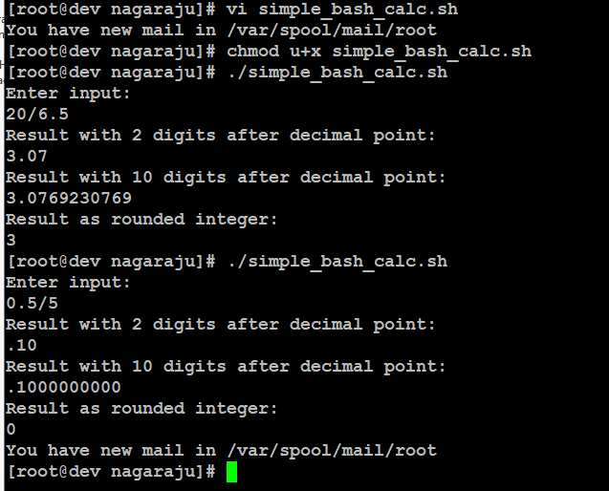

Figure 38: floating point calculations

### Redirections

#### STDOUT from bash script to STDERR

*#!/bin/bash*

*echo "Redirect this STDOUT to STDERR" 1>&2*

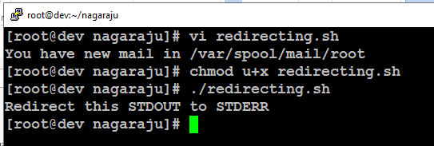

Figure 39: STDOUT from bash script to STDERR

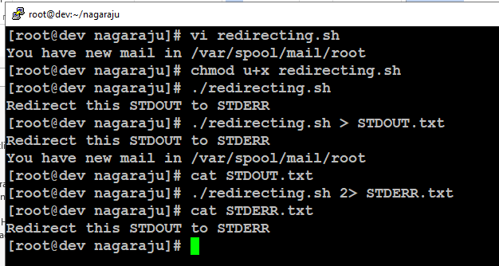

Figure 40: redirect script’s output to file

#### STDERR from bash script to STDOUT

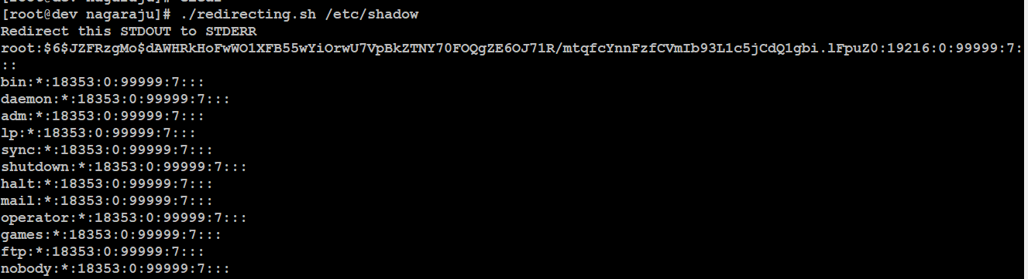

Figure 41: STDERR from bash script to STDOUT

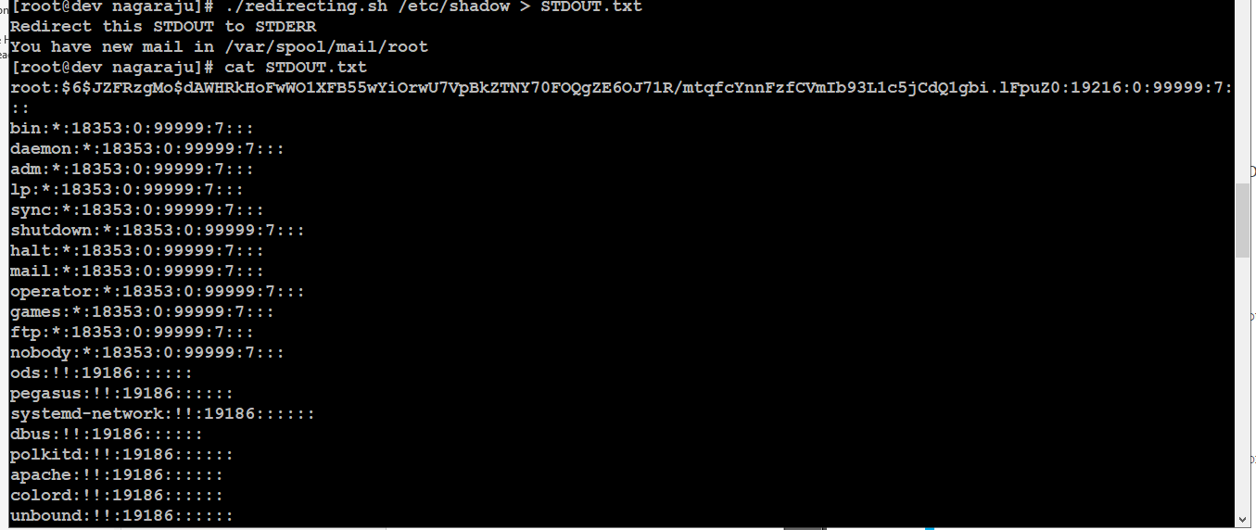

Figure 42: STDERR is redirected to STDOUT we can redirect script’s output to file

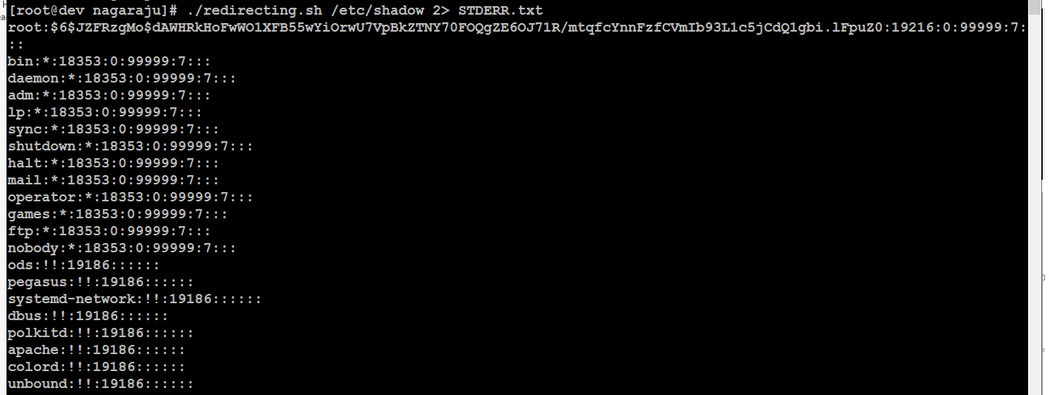

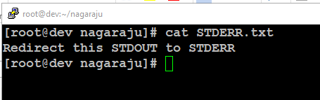

#### stdout to screen

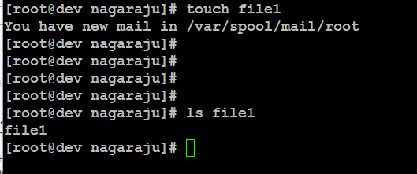

Figure 43: stdout to screen

#### stdout to file

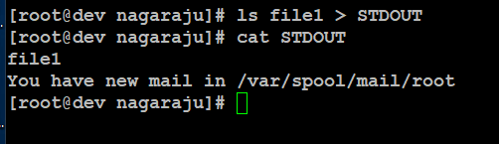

Figure 44: redirecting stdout to file

#### stderr to file

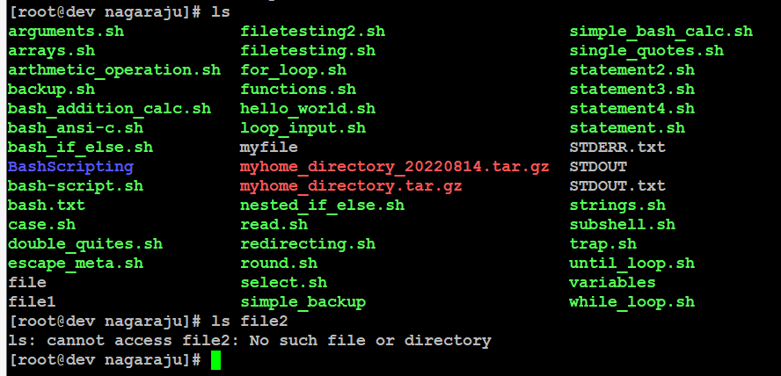

Figure 45: redirecting stderr to file

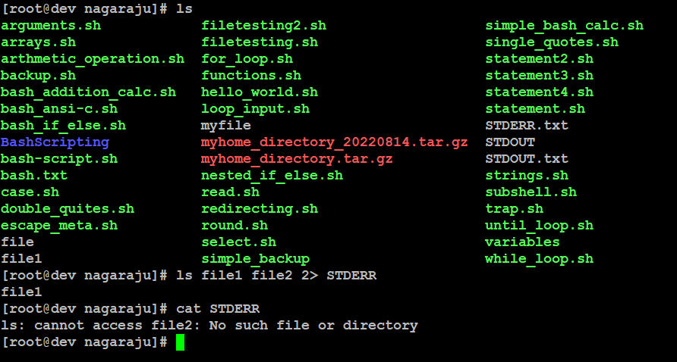

Figure 46redirecting STDERR and checking

#### stdout to stderr

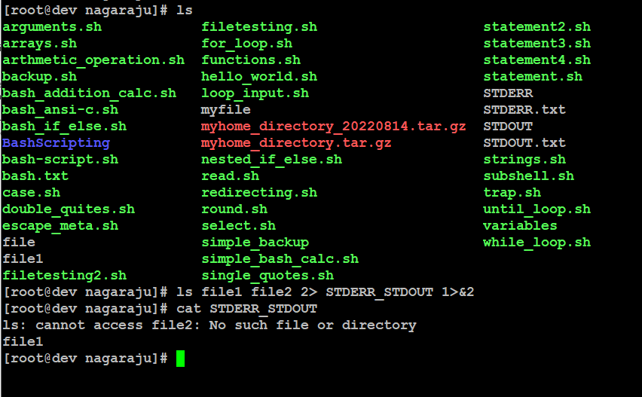

Figure 47: Redirecting stdout to stderr

#### stderr to stdout

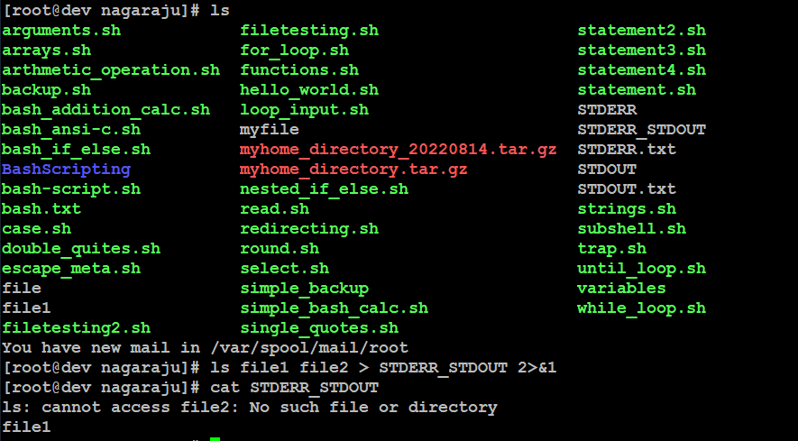

Figure 48: Redirectiong stdout to stderr

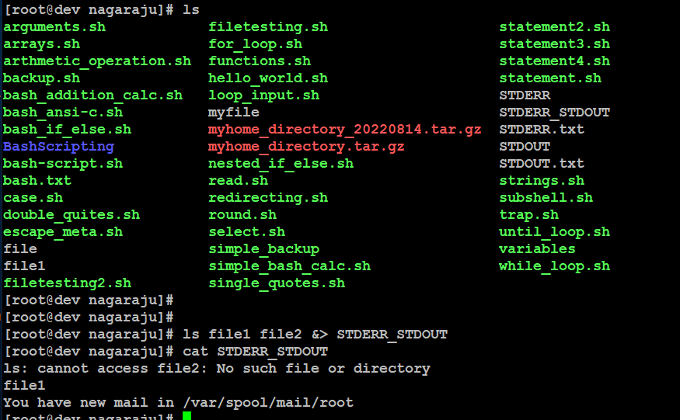

Figure 49: Another way to achieve the same effect is illustrated

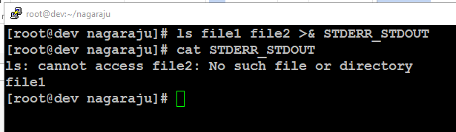

Figure 50: Checking redirected file